Accessibility Guide for Mount Cook Adventure Centre
explore@mountcook.uk, 01629823702, https://www.mountcook.uk/
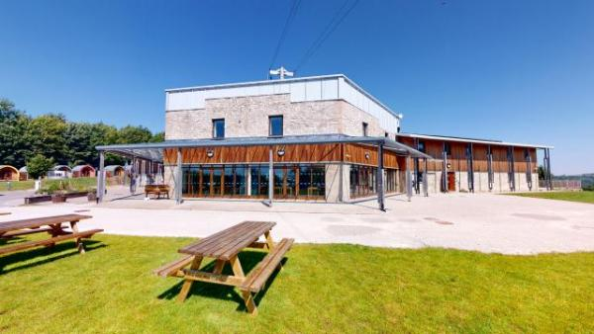

Welcome
Mount Cook Adventure Centre is a non-for-profit activity centre based just outside of the Peak District. We offer accommodation, catering, and exciting outdoor activities for all. Our adventurous activities are designed to broaden horizons, develop key skills and create lasting memories. We work with a diverse range of groups and individuals 365 days of the year for either residential trips or activity days. We can accommodate up to 180 people in a combination of modern bunk style en-suite bedrooms, glamping pods, and accessible bedrooms.

At a Glance

Level Access
- There is level access from the main entrance to:
  - Front Desk
  - Dining Table
  - Accessible bedroom Rooms 2 and 4
  - Activity Area - Indoor Climbing
  - Activity Area - Bushcraft/Woodland
  - Activity Area - High Ropes + Archery + Via Ferrata
  - Activity Area - Playing Fields
  - Activity Area - Low Ropes

Access with steps
- There are steps from the main entrance to:
  - Activity Area - Rooftop Rider Zip Wire
  - The Tipi

Bedrooms
- We have non-allergic bedding.

Level access bedrooms
- From the main entrance to the bedroom, there is level access.
- The route to the bedroom is 750mm wide, or more.
- The bedroom door is 750mm wide, or more.

Hearing
- The fire alarm has flashing lights.
- We have a hearing loop in All Communal Spaces.

Visual
- Glass doors and full-height windows have contrast markings.

General
- Staff are available 24 hours a day.
- Some staff have disability awareness training.
- We have emergency evacuation procedures for disabled visitors.

Getting here
Mount Cook Adventure Centre
Porter Lane
Middleton-by-Wirksworth
DE4 4LS

Travel by public transport
- You can get to Mount Cook Adventure Centre by bus.
- The nearest bus stop is a 3 minute walk away on Porter Lane, next to the Willows Direct building. There is a short stretch that does not have pavement and you must walk along the grass. The Sixes service 6.1 go from Derby bus station to Porter Lane. The Little Sixes also run between Matlock and Wirksworth, stopping on Porter Lane. The bus stop is 0.1 miles / 0.2 km / 5.8 km from Mount Cook Adventure Centre . The bus stop is 0.1 miles / 0.2 km from Mount Cook Adventure Centre.

Parking
- We have a car park. There are accessible parking spaces. The parking is less than 50 metres from the main entrance. Parking is free.
- There is a drop-off point at the main entrance. The drop-off point has a dropped kerb.
- From the car park to the entrance, there is level access. We have one disabled parking space directly outside the main entrance, with 6 additional spaces in the car park next to it. We have some overflow parking (approx 10 spaces) around the back of the centre, which have a gravel path leading to the main entrance (approx 30m away) and access to a back entrance (approx 10m away)
Our main carpark has parking for up to 40 vehicles, opposite our main entrance. It's a 2 minute walk up a small hill from the car park to the front door. There is a step at the pedestrian gate but you can buzz in and someone can open the level car entrence.
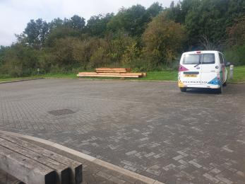
Parking in front of main entrance

Arrival

Path to main entrance
- From the street to the main entrance, there is level access.
- The path is sloped.

Main entrance
- The main entrance has level access.
- The door is 1800mm wide.
- The main door is side hung and automatic.
- We have wide double doors that open automatically when they are approached, and automatically stop opening if the censors detect someone in the way.
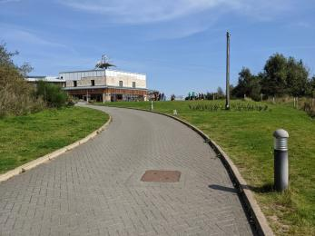
The Drive
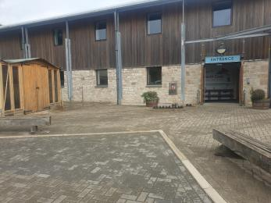
Entrance to centre with dropped kerb

Getting around inside

Visual Impairment - General Information
- We have contrast markings on all glass doors and contrast markings on all full-height windows.

Front Desk
- From the main entrance to reception, there is level access. You can sit down at reception.
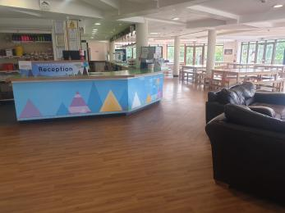
Reception with part of the seating area

Bedrooms
- Most bedrooms have windows.
- Bedrooms have ceiling lights, wall lights and natural daylight.
- All bedrooms are non-smoking.
- We have non-allergic bedding.
- All bedrooms have fitted carpets.
- We have wi-fi free bedrooms, for visitors with electro-sensitivity.
- We can move the bedroom furniture, to improve accessibility.
- From the main entrance to this area, there is level access.
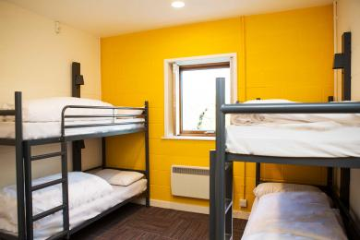
A Standard Bedroom

Place to eat and drink

Main Dining Hall
- From the main entrance to the dining area, there is level access. The door is 1600mm wide.
- To get to a table, there are no steps.
- The dining area is self-service. If you need table service, staff can help you.
- The route through the dining area is 800mm wide, or more.
- There is background music sometimes.
- The table and plates have high colour contrast.
- We cater for sugar free (diabetic), vegetarian, gluten free (celiacs), lactose free (dairy free), nut free, low fat, low potassium, low sodium, no gastric content, high fibre, vegan, kosher and halal specific diets.
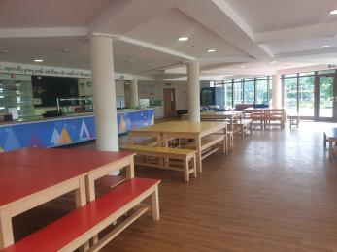
The dining area including seating and the food counter

Accessible bedroom Rooms 2 and 4
- From the main entrance to this area, there is level access.
- The route to the bedroom is 850mm wide, or more. The bedroom door is 850mm wide. There is 1800mm at the side of the bed. The bed is 400mm high. There is 250mm under the bed.
There is an emergency call system next to the bed.
The bedroom is double. The bathroom is ensuite. The bathroom door is 850mm wide.
The bathroom has a separate shower. The shower has a handrail.
The bathroom has a level access shower. The level access shower has a seat. There is a shower chair available. The level access shower has handrails.
The toilets have handrails. The direction of transfer onto the toilet is to the right. There is 1800mm at the side of the toilet.
There is 2000mm in front of the toilet. The toilet seat is 480mm high.
The basin is 730mm high. The taps are lever operated. There is space under the basin, with no pedestal.
The bathroom has an emergency call system.
The walls and the bathroom fittings have high colour contrast
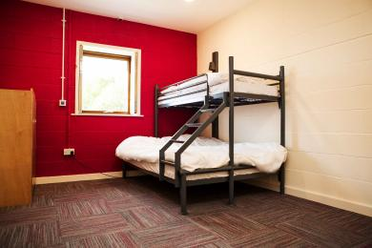
Accessible Bedroom
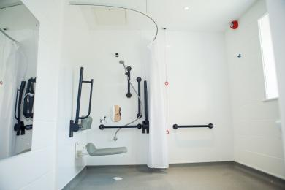
Accessible en-suite shower
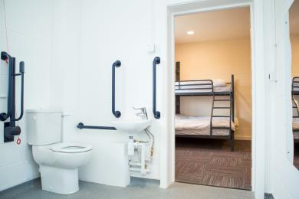
Accessible en-suite toilet

Activity Area - Indoor Climbing
- From the main entrance to this area, there is level access. The door is 850mm wide.
- The route to the Climbing is 850mm wide, or more. The door is 850mm wide.

Getting around outside

Activity Area - Bushcraft/Woodland
- From the main entrance to this area, there is level access. The entrance is 1600mm wide.
- The path to the woodland area includes either a short flight of stairs, or a longer route around the back of the centre on a flat gravel path. the entrance has a slight dip down. There is some rough ground that usually has a coverage of sticks and leaves. It can be muddy depending on the weather, and can have low light due to tree coverage
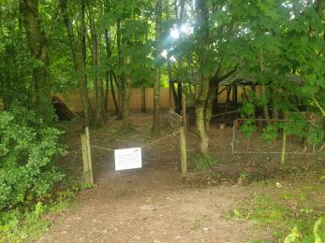
Entrance to the Bushcraft area
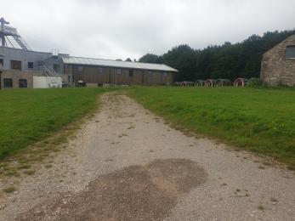
Gravel path with access to the Bushcraft area

Activity Area - High Ropes + Archery + Via Ferrata
- From the main entrance to this area, there is level access. The entrance is 1200mm wide.
- The route to the High Ropes and Archery is down a gravel path with a gentle decline, and then along a path next to a minature train track. The path next to the train track is 1500mm, but can become overgrown depending on the time of year. The High Ropes are in wood chips and on a slightly raised platform. The Archery is accessible through the High Ropes area, or down a gravel path with a medium decline. There is some rough ground with sticks, leaves, and stone, and the path can be overgrown at certain times of the year. The Via Ferrata is accessed through the High Ropes area, or down a gravel path with a medium decline and then through the archery area. There is also a rope bridge that has gaps between the planks and wobbles as a person walks across it.
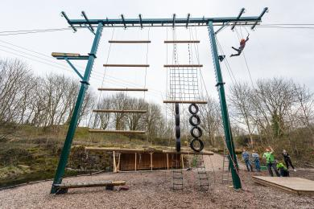
The High Ropes course
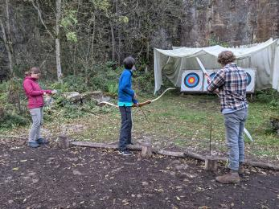
The Archery Area
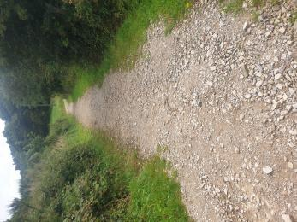
Gravel path to the Quarry
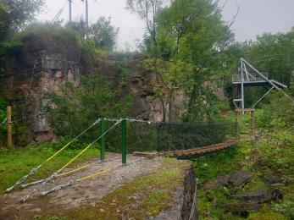
The Via Ferrata with the rope bridge and exit for the zip wire.

Activity Area - Playing Fields
- From the main entrance to this area, there is level access. The entrance is 1600mm wide.
- Our outside playing areas are used for a vairtey of activities such as team challenges, archery tag, and land karts. They are all accessible by a gravel path on a shallow incline, and are covered in grass
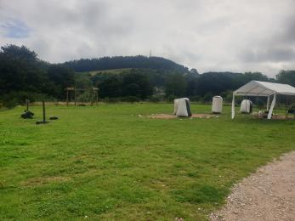
One of our playing fields
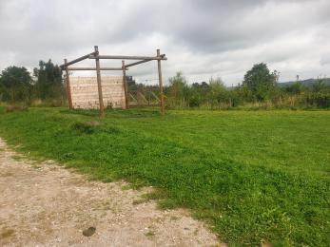
Our Second field with a notable grass bump

Activity Area - Rooftop Rider Zip Wire
- From the main entrance to the area, there are 30 steps.
- There are two options of stair case to reach our zip wire, and indoor staircase and an outdoor staircase. The indoor staircase is 20 steps, has a handrail, and has high contrast edges on the steps. The outdoor staircase is also 20 steps, and is made of metal. It can be slightly slippery if it has been raining. The stairs up to the zip wire platform are also metal.
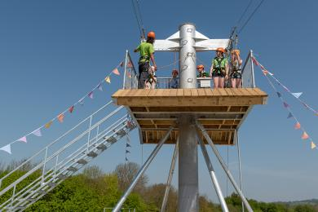
Stairs to zip wire platform
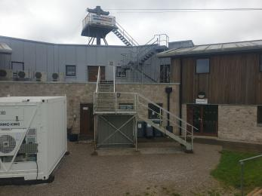
The external staircase to the zip wire

The Tipi
- From the main entrance to the area, there is 1 step.
- The Tipi can be used for various reasons, such as conferences, talks, storage, and meals. The Tipi is a few metres away from the entrance. There is a small Step up into the Tipi. The inside of the Tipi is flat.
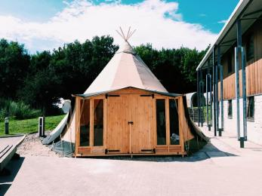
The Tipi

Activity Area - Low Ropes
- From the main entrance to this area, there is level access.
- The Route to the Low Ropes area is down the main drive. The main drive is a gentle slope and paved. The Low Ropes are on grass. The grass is maintained, but how regularly varies throughout the year. The ground is uneven in places.
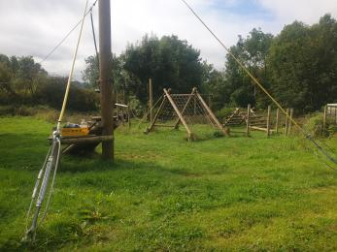
The Low Ropes
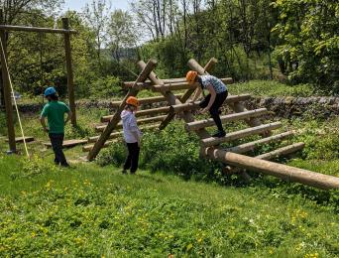
Children on the low ropes

The Dell
- The entrance and exit to The Dell is very narrow and steep with a stoney drop.

Customer care support

Accessibility equipment
- We have a hearing loop in All Communal Spaces.
- We generally do not allow dogs at Mount Cook unless they are service dogs. This means we do not have a designated toilet area for them. However, there are bins around the main entrance, and we just ask guests to clear up any mess
- We have an area to charge mobility scooters and battery powered wheelchairs.
- Mobility scooter batteries that are charged using a traditional 3 pin plug can be charged in bedrooms or at reception. Any larger electric vechicles (like cars) can be charged at our electric power point for a cost.
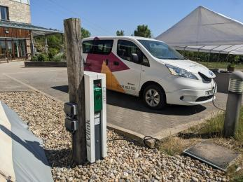
Electric Vehicle Charging

Emergency evacuation procedures
- We have emergency evacuation procedures for disabled visitors.
- The fire alarm has flashing lights.

Customer care support
- Some staff have disability awareness training.
- Staff are available 24 hours a day.
- All our permanent members of staff have Disability Awareness training. We have seasonal members of staff who may not. We don't offer any different formats for visitor information. However, if you let a member of staff know your preferences prior to your arrival, we will try our best to cater for your needs.
Staff are available Monday to Friday 9 - 5 via email and social media

Guide last updated: 23 August 2023

