Mount Cook Adventure Centre Accreditations
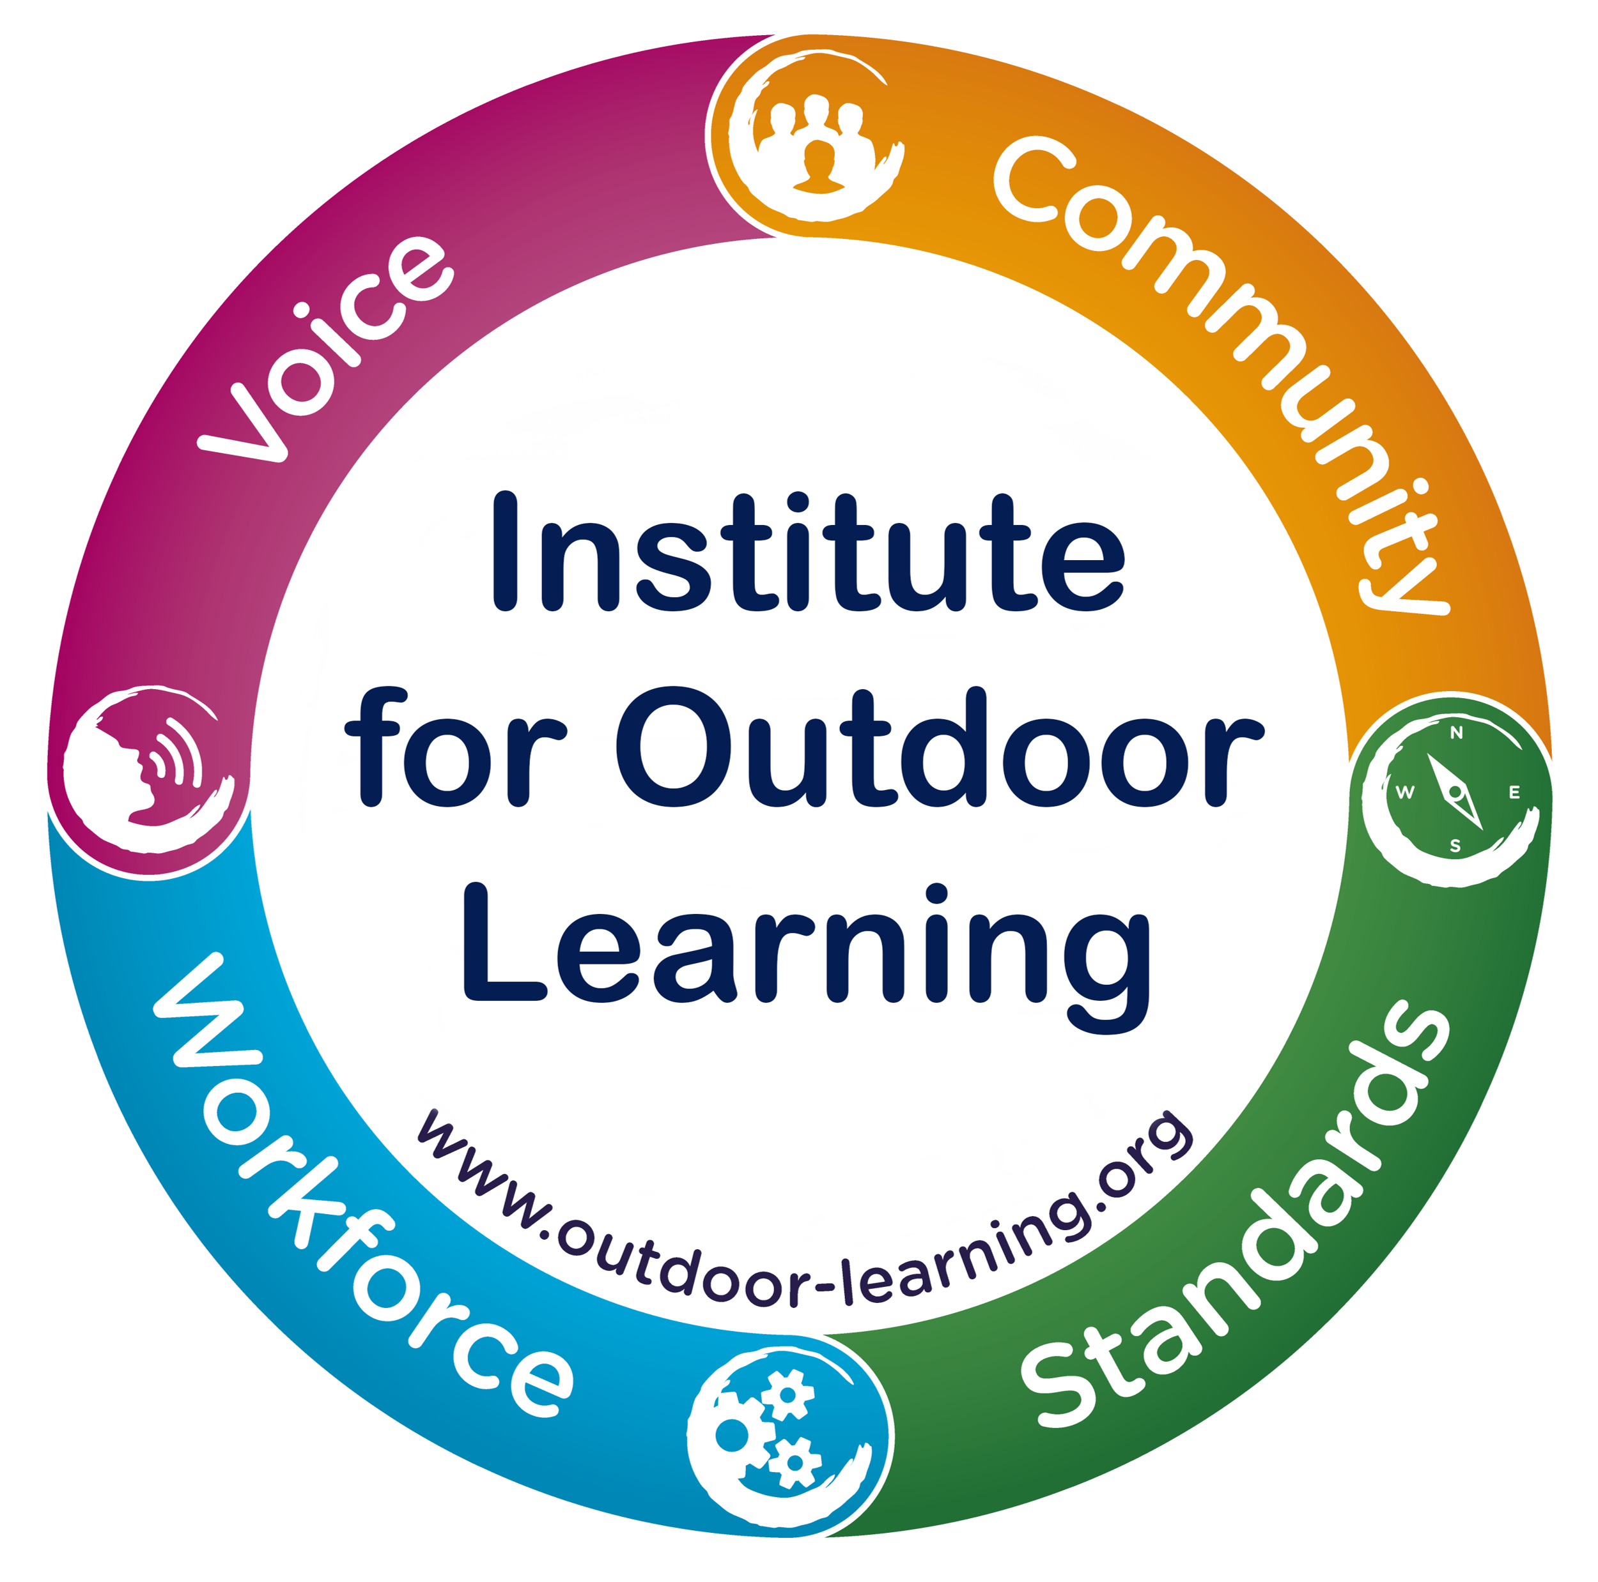
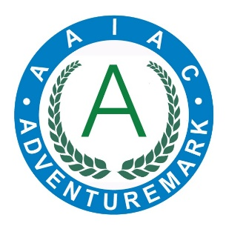
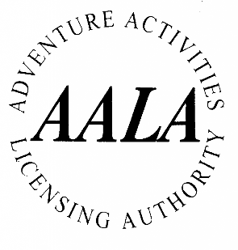
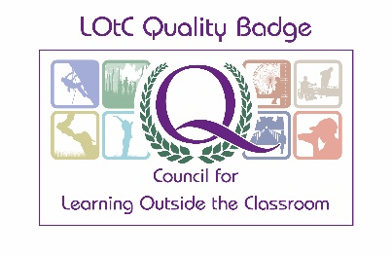
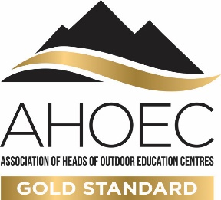
We are a highly accredited centre with many additional qualifications and quality marks. However, these are the accreditations we hold that are most likely to be useful to our customers during the booking process.
Institute for Outdoor Learning
Website: www.lotc.org.uk/educators/developing-your-lotc/find-a-lotc-quality-badge-holder
Our ID: Please find us listed on the above link

AAIAC Adventuremark
Website: www.adventuremark.co.uk/holders/holders/
Our ID: Please find us listed on the above link
All Providers who hold Adventuremark will have undergone an inspection to confirm compliance and good practice in delivering activities to young people.
AALA License – Climbing Category
Website: https://aala.hse.gov.uk/aala/provider_detail.php?ref_no=R2743
Our ID: L139383
Allows us to deliver abseiling, climbing and Via Ferrata.
Learning Outside The Classroom Quality Badge
Website: www.lotc.org.uk
Our ID: 103883
The DofE’s guidance on Health & Safety on Educational Visits recommends that schools look for the LOtC Quality Badge when choosing providers of educational visits.
AHOEC Gold Standard
Website: www.ahoec.org/gold-standard
Our ID: Certificate available here
Encompassing not just safety but also the quality of service and learning, the Gold Standard logo provides assurances to participants and customers.

